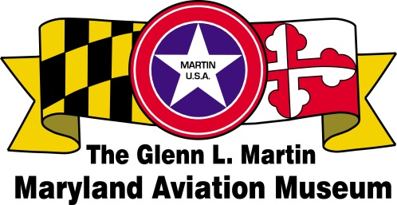

**Volunteer Application**

**BENEFITS OF VOLUNTEERING:**

* Opportunity to share skills and knowledge
* Up-close, behind-the-scenes view of the museum’s collections
* Satisfaction of making a major contribution to the museum and community.
* Gain new skills, make new friends, and have fun.
* Museum Guides learn about Mr. Glenn L. Martin, the Glenn Martin Company, his impact on the Middle River area and the planes on display at the static flight line at Strawberry Point.

Complete this form and mail to – GLMMAM, P.O. 5024, Middle River, MD 21220

.

Name __________________________________________________ Date _______________

Address ________________________________________________ Zip_________________

Phone ________________________________ Date of Birth_______________________

Email __________________________________________________________________________

In case of emergency notify: _________________________________________________________

Phone:______________________________ Relationship:______________________________



**AREAS OF INTEREST:**

___Aircraft

___Archive

___Education

___Finance

___Fundraising

___Gift Shop

___Grant Writing

___Membership

___Museum Guide

___Newsletter

___ Public Relations

___Technology

___Train Garden

___Other _______________

**NEW VOLUNTEER ORIENTATION**: Wednesdays throughout the year. Training varies based on areas of interest.

Email Kristine Connelly, Volunteer Coordinator, martinmuseum@gmail.com

Do not write below this line:

Mentor:

Date of Orientation:

Training Date: Revised Jan 2022