The Glenn L. Martin Maryland Aviation Museum
Holiday Plane and Train Garden

November 26, 2022 to January 15, 2023
Wednesday, Saturday, Sunday: 11 am to 4 pm
Check for additional dates and times at www.mdairmuseum.org

NEW LOCATION –
Lockheed Martin, 2323 Eastern Blvd., E-building, Conference Room E1D, Middle River, MD
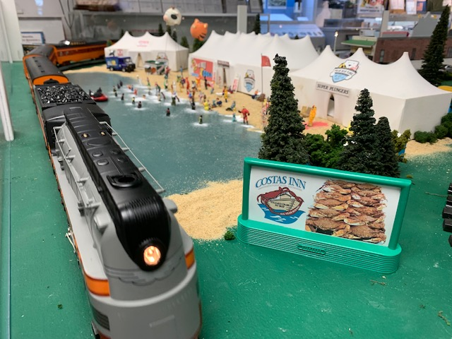
New Local Features:
      - Middle River Lighted Boat Parade
          - Fort McHenry
          - Stemmers Run Station
          - St. Stephen A.M.E. Church
Advertise your business here!
          - Hampden’s “Miracle on Thirty-Fourth
Street” Holiday Lights
      - Hochschild Kohn/Hutzlers
1960 Holiday Parade
          - And much more!

-- - - - - - - - - - - - - - - - - - - - - - - - - - - - - - - - - - - - - - - - - - - - - - - - - - - - - - - - - - - - - - - - - - - - - - - - - - - - - - - - - - -

SPONSORSHIP FORM - 2022 Holiday Plane and Train Garden
Company/
Organization: _________________________________________________________________Date:_____________

Address: ______________________________________________________________________________________

City, State: __________________________________________________________________Zip:________________

Contact Name: _____________________________________________________Phone: _______________________

Email: _________________________________________________________________________________________

___Yes, I would like to make a donation (without a billboard) in the amount of $_____________________

___Yes, I would like to make a donation for a billboard in the amount of $100.00 $_____________________
Attach your design or a business card for the billboard - 2 ¼” by 5”

Make check payable: GLMMAM. Total amount enclosed: $_____________________
Mailing address: GLMMAM, P.O. Box 5024, Middle River, MD 21220

