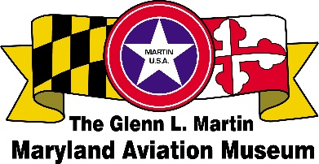
Maryland Fleet Week and Flyover Baltimore
Open House (Take-Off & Landing Zone) at Martin State Airport
701 Wilson Point Road, Middle River, MD 21220
Saturday and Sunday, June 15 -16, 2024 from 10 am to 4 pm
VENDOR/COMMERCIAL/PROMOTIONAL BOOTH APPLICATION
Check One | Type of Vendor | SINGLE SPACE  Two days | SECOND SPACE  Two days | TOTAL FEE
 | Food vendor fee: $250. for 10’X15’ space. One additional 10’X15’ space can be rented for $100. Electricity WILL NOT be supplied for food vendors. | $250. | $100.
 | Commercial/promotional booth fee: $150. for 10’X15’ space. One space per applicant. Electricity WILL NOT be provided for commercial/promotional booths. | $150. | $100.
 | Arts and Crafts vendor fee: $100. for 10’X10’ space. One additional 10’X10’ space can be rented for $50. Please submit photographs of the items for sale. Electricity WILL NOT be provided for arts and crafts vendors. | $100. | $50.
 | Non-profit organization: Free for 10’X10’ space. Electricity WILL NOT be provided for non-profit organizations. | Free | $50.
 | Donation to the Museum – Any amount is accepted. | -- | --
CONTACT INFORMATION
(Please list organization name and website as it should be listed in promotional materials.)
Business/Organization:
Owner:
Address of Business:
Address of Owner:
Phone numbers of owner: Home/Business/Cell
Email:
Website:
Contact Information (If other than owner):

DESCRIPTION OF YOUR DISPLAY/ACTIVITY:
The festival committee reserves the right to deny the application due to space considerations or other reasons. No refund unless the event is cancelled. Certificate of Liability Insurance, and Food Service Facility Permit from Baltimore County Department of Health (410-887-3663) are required at time of payment..
Please send paperwork and payment (payable GLMMAM):
The Glenn L. Martin Maryland Aviation Museum, P.O. Box 5024, Middle River, MD 21220
For more information contact Joe Corteal at martinmuseum@gmail.com
Signed:____________________________________________________ Date:__________________________

