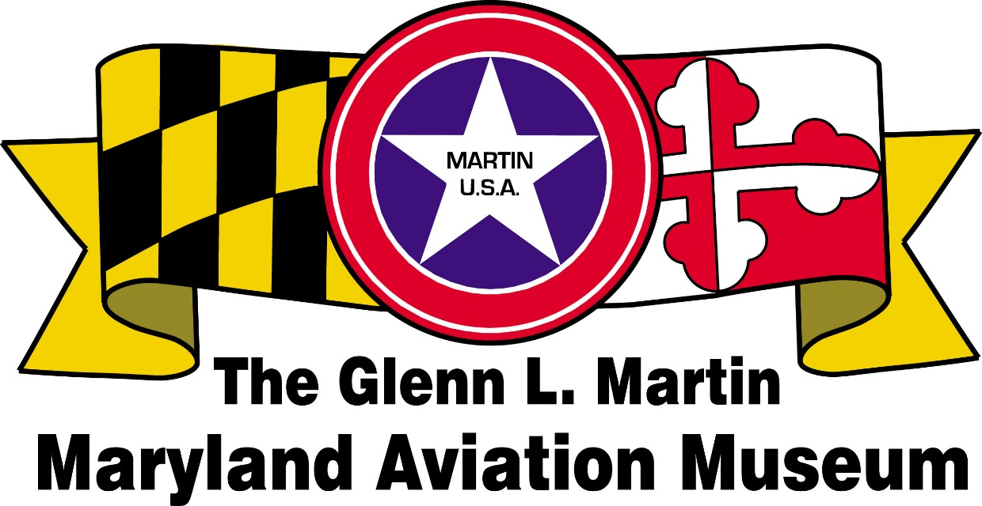

Volunteer Application

BENEFITS OF VOLUNTEERING:
- Opportunity to share skills and knowledge
- Up-close, behind-the-scenes view of the Museum’s collections
- Satisfaction of making a major contribution to the Museum and community.
- Gain new skills, make new friends, and have fun.
- Museum guides learn about the history of Mr. Glenn L. Martin, and his impact on the Middle River area and the aircraft on display at the static flight line located at Strawberry Point

Complete this form and mail to – GLMMAM, P.O. 5024, Middle River, MD 21220

Name ________________________________________ Date:_______________

Address_________________________________________ Zip_______________

Phone _______________________________ Date of Birth__________________

Email _____________________________________________________________

In case of emergency notify ____________________________________________

Phone:_________________________ Relationship:_________________________

Museum membership is encouraged. Do you want a membership form? Yes___No___.

AREAS OF INTEREST (Please check.):
Aircraft | Gift Shop | Public Relations
Archives | Grant Writing | Restoration
Education | Membership | Technology
Finance | Museum Tour Guide | Train Garden
Fundraising | Newsletter | Other

NEW VOLUNTEER ORIENTATION: Wednesdays throughout the year. Training varies based on areas of interest. Contact Volunteer Coordinator, martinmuseum@gmail.com.
Do not write below this line.
Volunteer Handbook/Volunteer Acknowledgement:
Job Description:
Date of Orientation: Date Requested Name tag:
Mentor: Date Entered Past Perfect:
Training Date: Revised December 2023

