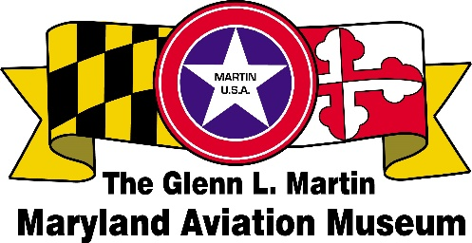
Sponsor Application

The Holiday Plane and Train Garden

Open: November 29, 2025 to January 4, 2026
Wednesday, Friday, Saturday, Sunday: 11 am to 4 pm
Open Extra Days: Monday, December 29; Tuesday, December 30
Check the website for cancellation due to unforeseen circumstance.

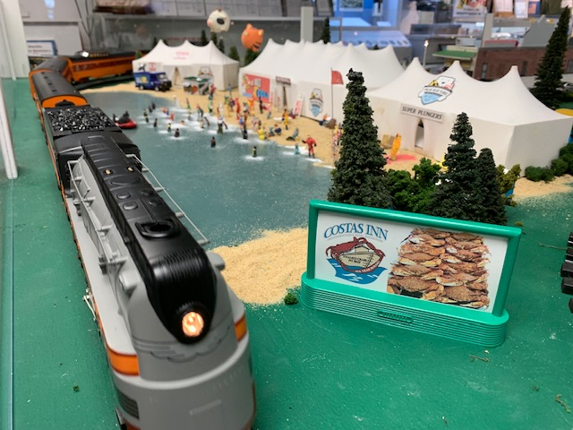
Features:

- Walt Disney World

- Heritage Society of Essex and Middle River
Advertise your business here!

- Stemmers Run Train Station

- And much more!

LOCATION OF DISPLAY – Maryland Aerospace Heritage Center
2323 Eastern Boulevard in Middle River, Maryland

-- - - - - - - - - - - - - - - - - - - - - - - - - - - - - - - - - - - - - - - - - - - - - - - - - - - - - - - - - - - - - - - - - - - - - - - - - - - - - - - - - - -
SPONSORSHIP APPLICATION - 2025 Holiday Plane and Train Garden
Company/
Organization: _________________________________________________________________Date:_____________

Address: ______________________________________________________________________________________

City, State: __________________________________________________________________Zip:________________

Contact Name: _____________________________________________________Phone: _______________________

Email: _________________________________________________________________________________________

___Yes, I would like to make a donation (without a billboard) in the amount of $_____________________

___Yes, I would like to make a donation for a billboard in the amount of $100.00 $_____________________
Attach your design or a business card for the billboard - 2 ¼” by 5”

Make check payable: GLMMAM. Total amount enclosed: $_____________________
Mailing address: GLMMAM, P.O. Box 5024, Middle River, MD 21220

